# Question 01

# A

### Code

function out=Q01_a(A)

% A=[3 -2 4;-2 6 2; 4 2 3]

[r,c]=size(A);

temp=[];

if (~isequal(r,c))

disp('Dimension not equal ')

else

for i=1:r

if(isequal(A(i,:),A(:,i)'))

temp=[temp 1];

else

temp=[temp 0];

end

out=all(temp);

end

end

end

### Output

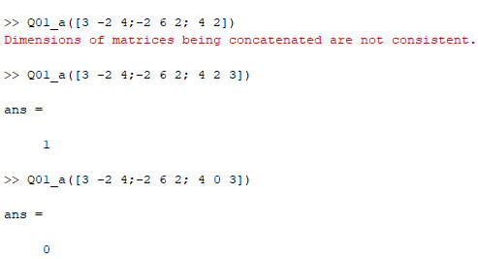

# B

### Code

clc

clear all

for i=1:10

A=randi([-3 3],2)

Q01_a(A)

end

### Output

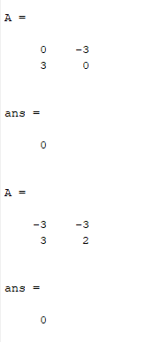

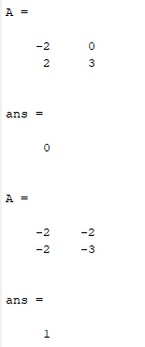

# Question 02

# A

### Code

clc

clear all

n=input('enter the n:');

while (1)

if(n>100)

n=input('Re_enter the value of n:');

elseif (n<10)

n=input('Re_enter the value of n:');

elseif(mod(n,2)==1)

n=input('Re_enter the value of n:');

else

break

end

end

matrix_=[];

for i=3:n-2

matrix_=[matrix_;3:n-2];

end

a=[ones(n-4,2) matrix_ ones(n-4,2)];

b=[ones(2,n);a;ones(2,n)];

b(n/2,n/2)=1;

b(n/2,n/2 + 1)=1;

b(n/2+ 1,n/2)=1;

b(n/2+ 1,n/2 + 1)=1;

disp('matrix')

b

%part b

imagesc(b)

### Output

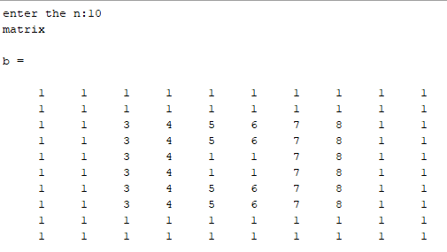

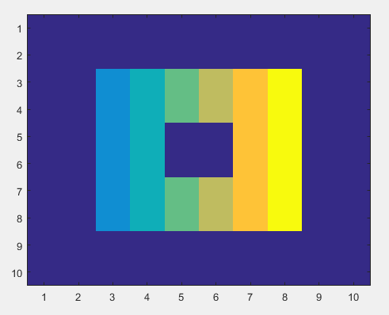

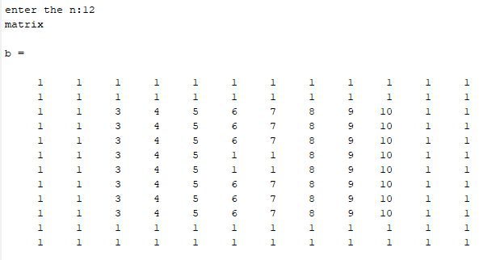

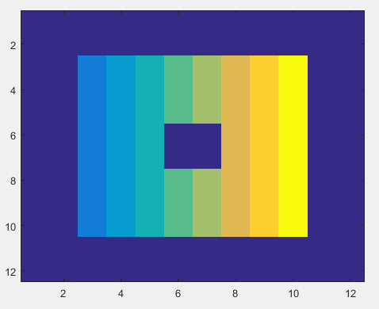

# Question 03

# A

### Code

clc

close all

clear all

x1=[1 cos(pi/12) cos(pi/6) cos(pi/4) cos(pi/3) cos(5*pi/12) cos(pi/2) -cos(5*pi/12) -cos(pi/3) -cos(pi/4) -cos(pi/6) -cos(pi/12) -1];

l=length(x1);

for i=1:l

y1(i)=sqrt(1-(x1(i)^2));

end

subplot(121)

plot(x1,y1)

yr1=-y1;

hold on

plot(x1,yr1)

x2=0.02*x1-0.4;

y2=0.02*y1+0.4;

yr2=-y2+0.8;

plot(x2,y2)

plot(x2,yr2)

x3=0.02*x1+0.4;

y3=0.02*y1+0.4;

yr3=-y3+0.8;

plot(x3,y3)

plot(x3,yr3)

x4=[0 0.05 0.1 0.15 0.2 0.25 0.3];

l1=length(x4);

for i=1:l1

y4(i)=2*(x4(i)^2)-0.4;

end

% plot(x4,y4)

x5=-x4;

plot([-0.2 0.2],[-.4 -.4])

% plot(x5,y4)

x6=[0 0 0];

y6=[-0.1 0 0.1];

plot(x6,y6)

axis([-2 2 -4 2]);

plot([0 0],[-1 -2])

plot([0 .5],[-1 -2])

plot([0 -.5],[-1 -2])

plot([0 .5],[-2 -3])

plot([0 -.5],[-2 -3])

text(-1,1.5,'I hate matlab')

subplot(122)

plot(x1,y1)

hold on

plot(x1,yr1)

plot(x2,y2)

plot(x2,yr2)

plot(x3,y3)

plot(x3,yr3)

plot(x4,y4)

plot(x5,y4)

plot(x6,y6)

axis([-2 2 -4 2]);

plot([0 0],[-1 -2])

plot([0 1],[-1.2 -.8])

plot([0 -1],[-1.2 -.8])

plot([0 1],[-2 -3])

plot([0 -1],[-2 -3])

text(-1,1.5,'I Love matlab')

### Output

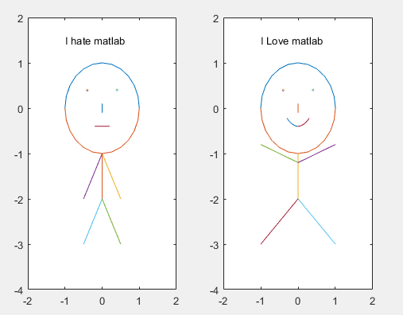

# Question 04

## Code

clc

clear all

close all

img=imread('Capture.PNG');

subplot(131)

imshow(img)

title('original image')

gray=rgb2gray(img);

[rows col]=size(gray);

upperHalf=gray(1:floor(rows/2),:);

bottomHalf = gray(floor(rows/2)+1:end,:);

invert=imcomplement(bottomHalf);

new_gray=[upperHalf;invert];

subplot(132)

imshow(new_gray)

title('gray and half bottom inverted')

% part b

imgRGB=img;

[r, c, ~] = size(imgRGB);

r = round(r/2);

imgRGB([r:end],[1:c],1) = rgb2gray(imgRGB([r:end],[1:c],:));

for i = 2:3

imgRGB([r:end],[1:c],i) = imgRGB([r:end],[1:c],1);

end

subplot(133)

imshow(imgRGB)

title('half gray and half color ')

## Output

